**Meeting Time:** 9:00 am – 1:30 noon 2022.12.05

**Attendees:** Xia Jiang, Zhen Yang

**Meeting agenda**

1. Reviewed progress made in the past week.
2. A thorough test of the current version of iMedBot-Dev, both prediction and model training.
3. Made comments and suggestions based the testing results.
4. Work assignment.

**Issues/Questions and Comments**

Jiang’s new comments based on the testing of iMedbot-test done during today’s meeting.

Regarding Model Prediction:

1. The values of a predictor should be ordered. For example (See below), the values of the t_tnm_stage, n_tnm_stage, grade, … should be ordered according to how it was explained and/or common sense. Graphical user interface, text, application

   Description automatically generated

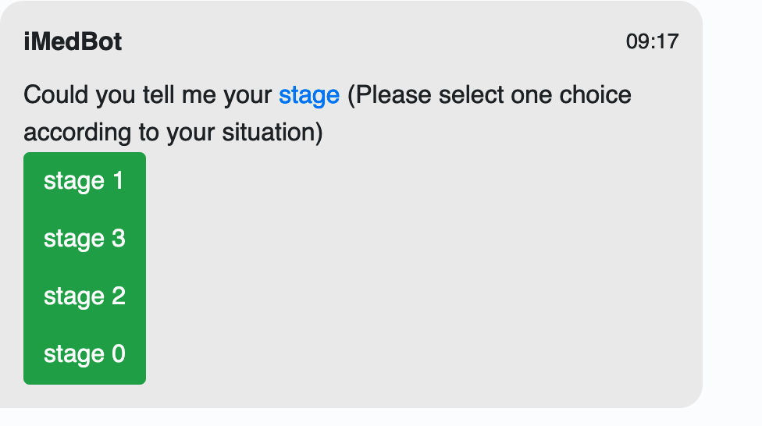

1. Need to fix the problem we discovered during meeting, with which a user can’t go back to the previous page when click on the 🡨-- key, rather it showed something like this. This was a previous comment, but not yet resolved.

New comment regarding this: If fixing this is not doable, then consider add a button, by which a user can go back to the previous page rather than restart all over.

1. When an error message shows up, and the user clicked on OK, the prompt should go back to the spot where the error occurs. For example, when error message is generated due to the fact that the user-selected dataset does not match the required dataset for 10-year model training (see below), then we should go back to the dataset selection page rather than the “prediction or model training” page as it showed during the testing. This was from previous meeting, but not yet resolved.

1. It is good that DCIS_level (see below) is now linked to a separate paper for further explaining the meaning of the values, but question is how the user will know there is a link and where is link is located, especially when the DCIS_level already has a “hover around” explanation. My suggestion is to add the word “Values” somewhere and make it a link to the separate page, and tell user about where this link is directly.

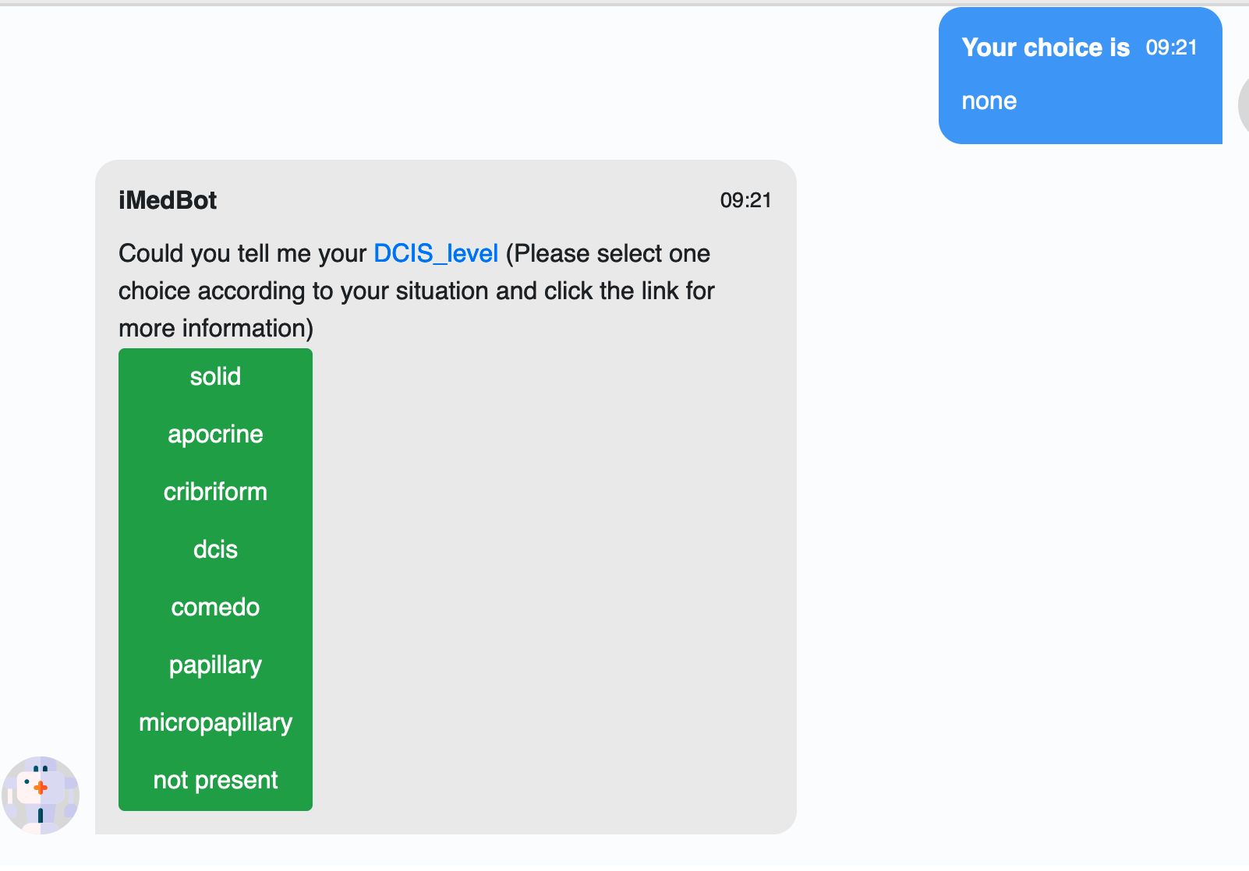

1. Need to fix the “logic” of the program, perhaps in many spots. For example, during the test, my dataset was rejected, but I can still click on the “view your dataset”, then once a user clicks on the button, the program paused. This comment is from previous week. Some might have been fix, but more discovered during the text today, such as the choice of hyperparameter value input. Continue to fix the logic flow everywhere, think from the standpoint view of a user. The bottom line is not to confuse user and always user friendly (intuitively).
2. I notice that we need to reword/revise our sentences in many places. For example (See below) the “patient risk of breast cancer recurrence” misses the information of the “year“, and note breast metastasis is not exactly the same as the “breast cancer recurrence”. We should just say the “patient risk of 5-year (or 10-year …) breast cancer metastasis”. Another example is “we are calculating the recurrence” is not accurate. I wonder what is the purpose of the whole sentence. If it is absolutely necessary to have this sentence, we could just say “Thank you, your patient information entry is complete and will be used by our program.” A third example, the whole sentence “What is the following thing you would like to do” does not sound smooth to me. We could just say “Which task would you like to do next?”

Further more, rather than repeat the same sentence “Please select one choice according to your situation” in many places, you can separate the difference choices (buttons) more obviously if possible. Currently, all choices appear to be a one big button. One possible solution is adding an outline in different color to each of the choice button.

Finally, when a “Send” button at the bottom, which is not used. This is the legacy when we allow a user to enter random questions, which did not seem to work at the time. It should be removed now and can be readded in the right spot in the future if we decide to go back the random conversation mode. This can be considered as one of the “logic” issues as mentioned previously.

1. Another rewording example below. “Could you tell me your ER?” is can be replaced by “Could you select the ER status of your patient”. Again, we assume that the iMedBot is talking with a researcher or a medical professional instead of with a patient directly. So the questions should be asked by keeping in mind whom you are talking to. Please check on this throughout the program.

1. Order of the predictors also matters, see blow. I would say it would be more intuitive if ER_percent follows the ER, rather than the current situation in which PR_percent follows the ER. Please ensure the predictors appear in the same order as they appear in the original dataset for all three years. I wonder why the order has been changed, for example, in original dataset, the PR_percent follows PR, but now PR appears way behind PR_percent, which should not happen even if some of the features were removed.

About model training

1. Again, please pay attention to wording. For example, what is “Model method description”? Could it be better to say “About model training” …. Or “About ‘Train a Model’ service”. Consider changing the service name from “Train a model” to “Model training”. The paragraph about the model training can be further refined.

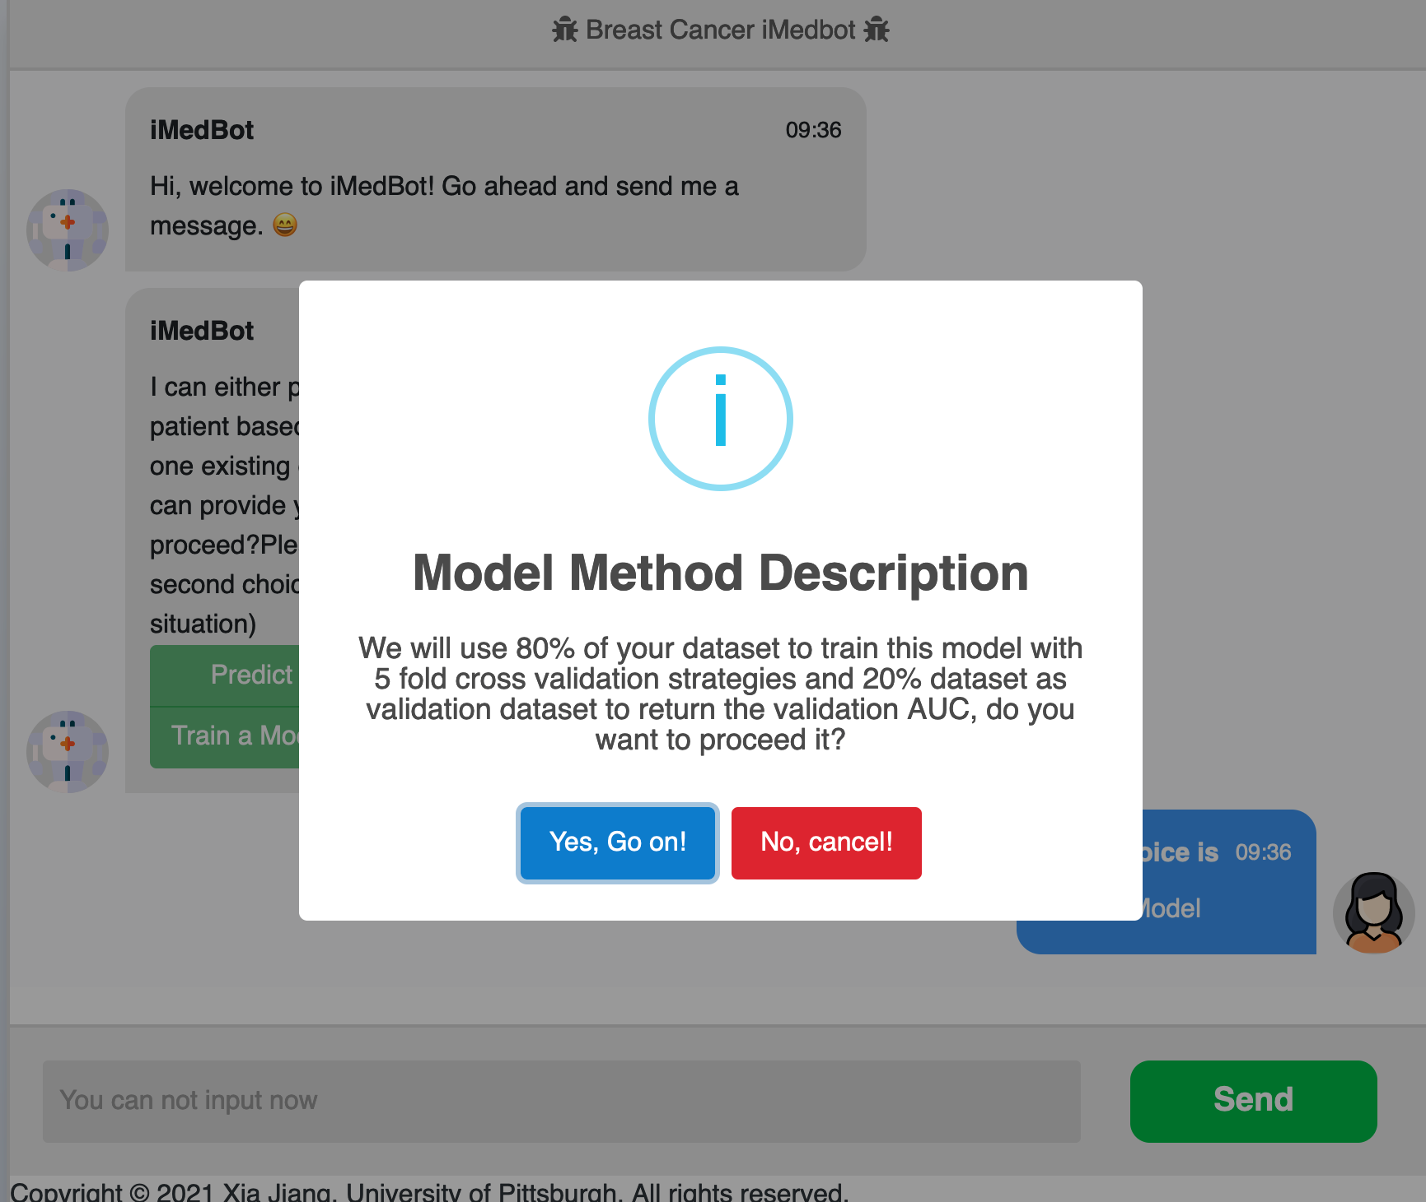

1. Need to change the current logic in term of the user choice of the hyperparameter values input. Once the user choose default, then should go with default, rather than re-prompt for the same choice gain.

1. Besides, the default should be appeared and explained better before the user makes selection. See the last screenshot above.
2. For the hyperparameters that we decide to set as default such as the current mstruct, there is be a good reason, and then it should not show to confuse user. See the last screenshot.
3. Hyperparameters should be better explained somewhere (see the last screenshot above). What is mstruct, what is drate …. We should not assume that user knows the meaning of these terms.
4. Please better expain your results, such as what is AUC, and how a user should interpret the result.

1. Error testing “Predicting for new patients”. See blow.

1. The mechanism for user selecting values did not go smoothly during test. See blow. Need to resolve.

Why learning rate and batch size have different size of font? Again, Learning rate and Batch size and other user input values can be better explained.

1. When a user dataset is rejected (see example below), please add a mechanism so that a user can go back to the previous page rather restart. A similar problem was already mentioned previously. Need to resolve all similar issues.

1. The large user dataset issue. During the test today, the 52 MB dataset that Dr. Jiang chose did not work and the program just paused, and not further hints for user. Suggestions: 1) Do a thorough test on your computer and give hint to user based on your test, such as given a computer hardware information, what is the maximum size of user dataset expected; 2) If user selected an very large dataset that is not expected not working with our current system, we should reject it and give a reason; 3) In case the training service is working properly as happened today, we should give a message explaining why (such as slow internet at the user site), and give prompt for further action.

**Ongoing tasks that cover more than a week**

Revise and Improve IMedBot

Tasks will include but are not limited to the following:

1. Revised the current version. Many things, and I will write about them in the specific task for the coming week.
2. Resolve the “deployment” crisis. Currently, we all work on the main branch. When we make a change and push to github, it will trigger an automatic deployment on the AWS site, in which case AWS will charge us. Another problem is when there is a crash in the development work, the main branch will also be affected. Potential solutions: 1. Look into writing our own deploy pipeline without using the paid service (Conder doing this eventually perhaps next year, when you get really familiar with the system). 2. Looking into established a developmental branch, which will not be deployed automatically, but with which we can do development and testing work and conveniently merge it to the main branch for deployment once the new features are confirmed.
3. We will incorporate google analytics to the iMedBot.
4. We will develop a user online survey for the model training service. We currently have a simple online survey for the prediction service, but we don’t have one developed for the model training service call. We plan to further enhance the current survey and develop a new one that is tailored to the model training service
5. We will develop a user registration system that is currently missing;
6. We will develop a backend database during the expansion project. The iMedBot currently does not have a backend storage which can be used to store proper information such as user registration information and user feedback collected via online survey results. The information stored in such a database can be very useful to further improve the quality of the serviced provided by the iMedBot;
7. We will develop an online user manual during the expansion award;
8. We will develop online videos for further user guidance;
9. We will develop a Trello board that would be connected to our current github repository for iMedBot. The Trello board will further promote user-developer interactions and encourage the user involvement in the development work such as testing and providing feedback in real time. It will automatically update the users with the newest development of the iMedBot and inform the developers the user feedback.

**Specific tasks for the coming week (continued with the previous meeting assignment)**

Zhen Yang did pretty good work this week to fix the problem of iMedbot and further improve its usability, keep up! For the coming week, the main task is still to improve iMedbot and resolve issues according to but not limited to my comments above. Next week, we will retest iMedbot during the meeting.

**Less urgent tasks**